1. What is the mean for this set of numbers?
7, 12, 5, 10, 8, 6, 7, 19, 13, 5

a. 7
b. 7.5
*c. 9.2
d. 14
e. 19

2. What is the range for this set of numbers?
7, 12, 5, 10, 8, 6, 7, 19, 13, 5

a. 7
b. 7.5
c. 9.2
*d. 14
e. 19

3. Reading the dial calipers below, the correct measurement is
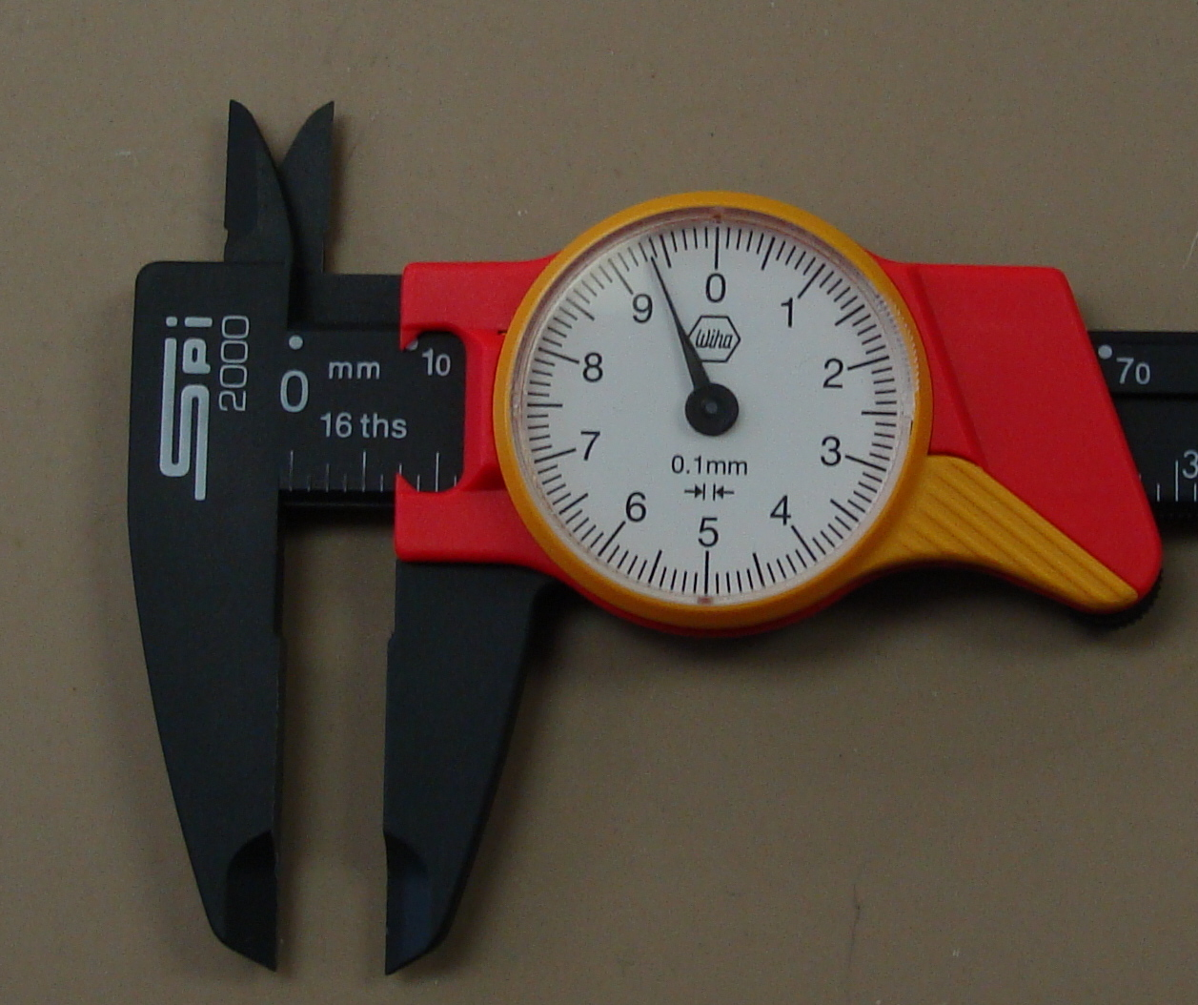

a. 9.3 cm
*b. 0.93 cm
c. 1.93 cm
d. 9.4 cm
e. 0.94 cm

4. This is what type of graph?
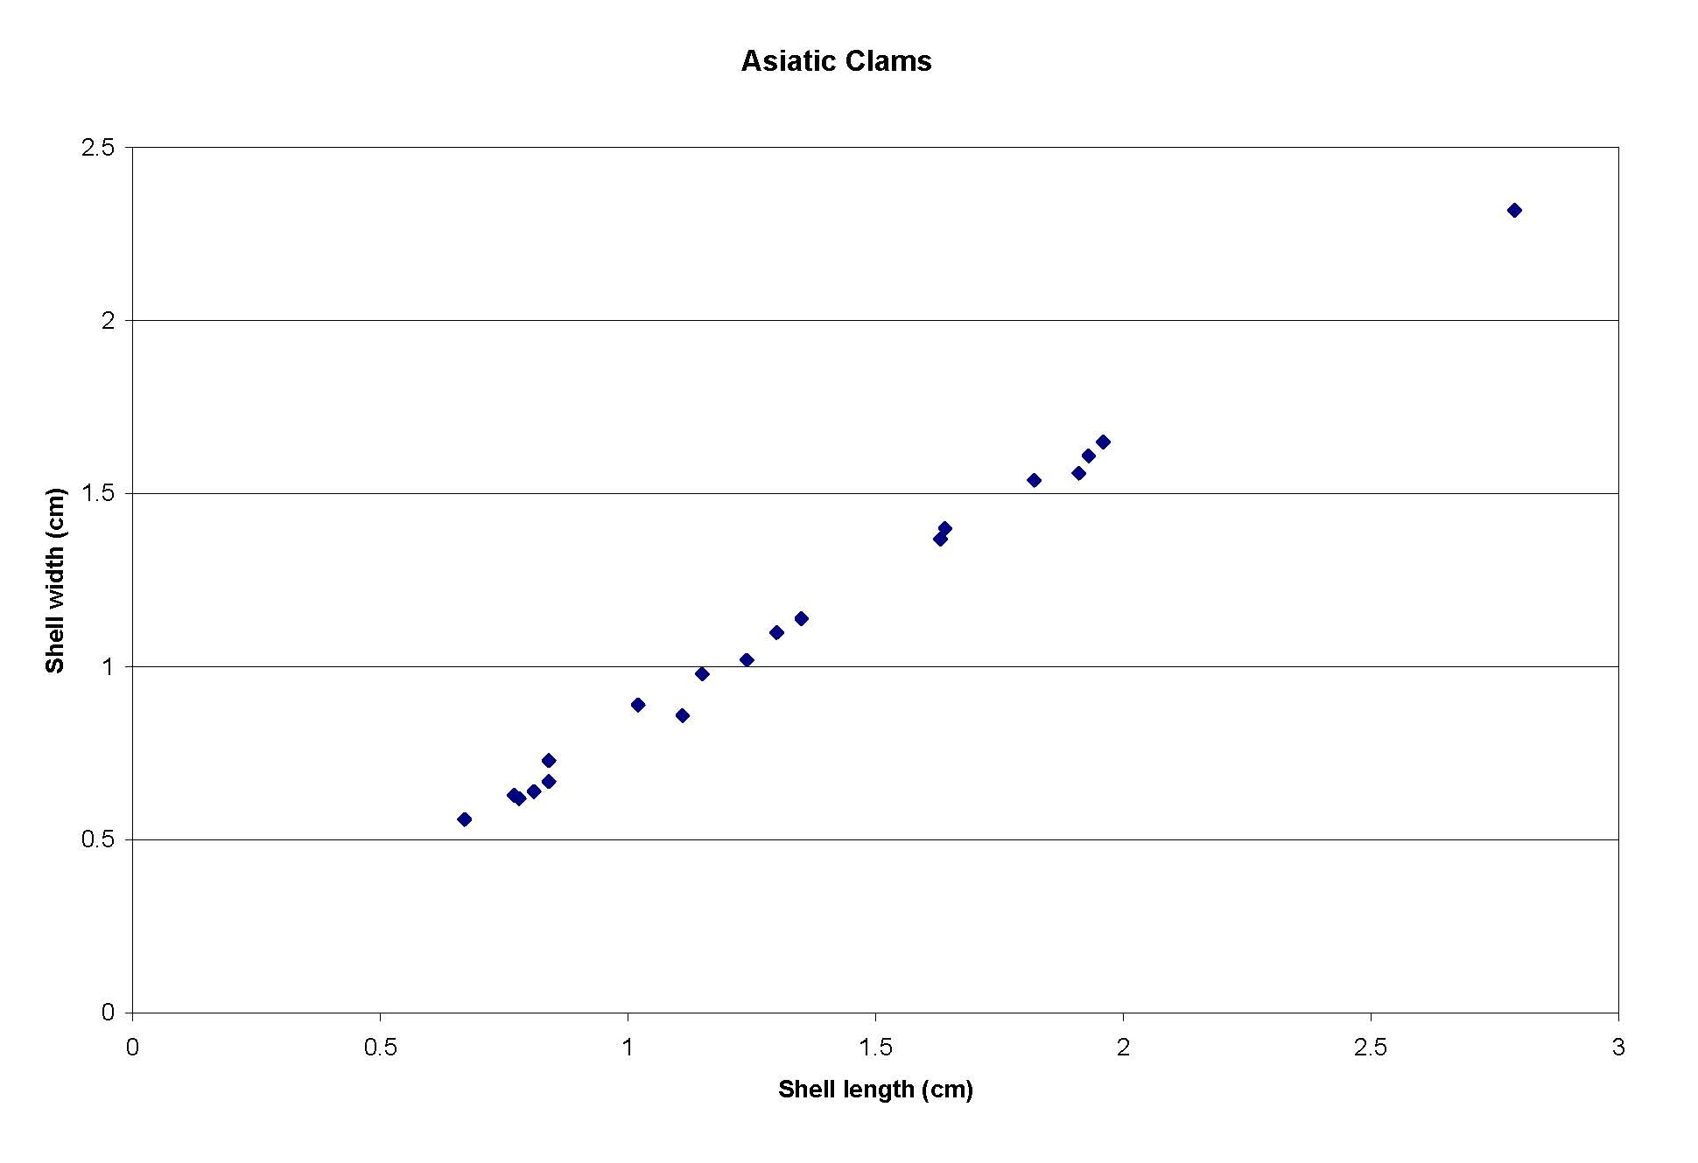

a. histogram
b. bar graph
*c. scatter plot
d. pie chart

5. The eastern fox squirrel, Sciurus niger, is typically 522 mm long with an average
tail length of 245 mm, average hind foot length of 72 mm, and weight of 600-
1300 g. What is the average tail length in cm?
a. 2450 cm
b. 245 cm
*c. 24.5 cm
d. 2.45 cm
e. 0.245 cm

6. The eastern fox squirrel, Sciurus niger, is typically 522 mm long with an average
tail length of 245 mm, average hind foot length of 72 mm, and weight of 600-
1300 g. What is the weight range in kilograms?
a. 6-13 kg
*b. 0.6-1.3 kg
c. 0.06-0.13 kg
d. 6000-13,000 kg
e. 27.27-59.09 kg
f. 272.7-590.9 kg

